HAB Tracking at Breakfast

HABAXE2, a Pico high altitude balloon tracker was launched around 09:30 on the 4th January 2015, from Caerphilly Common, 51.5621N 3.2228W. It was last heard of at Latitude 44.1618N, Longitude 4.3205E at an altitude of 8032M, having travelled just over 1000km.

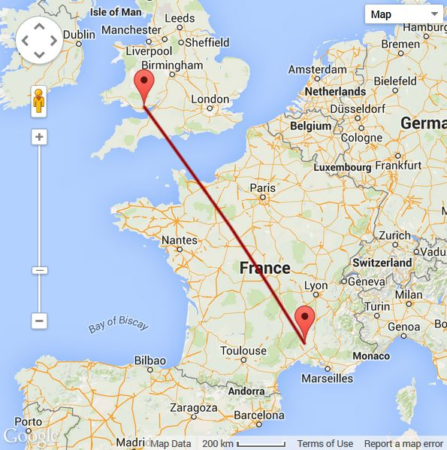

HABAXE2 used a PICAXE 28X2 and the Hope RFM98 radio transceiver designed for use in the 434Mhz ISM bands. This Pico balloon tracker weighed around 16g with a 10g 380mahr Lithium Polymer battery and was attached to a 36” foil balloon, filled with helium and adjusted for 2g of free lift. The RFM98 radio transceiver was sending the UKHAB compatible tracker packet as FSK RTTY and the same data as LoRa digital telemetry.

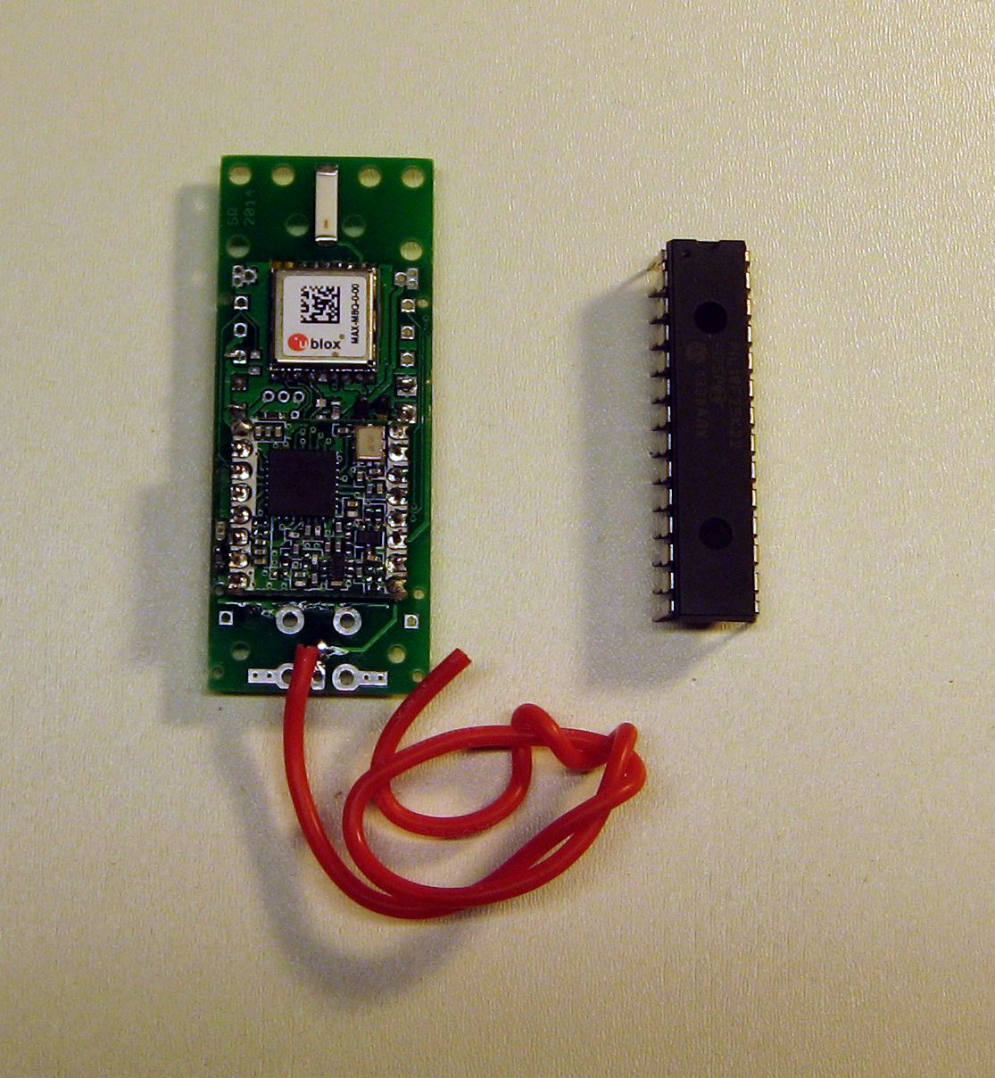
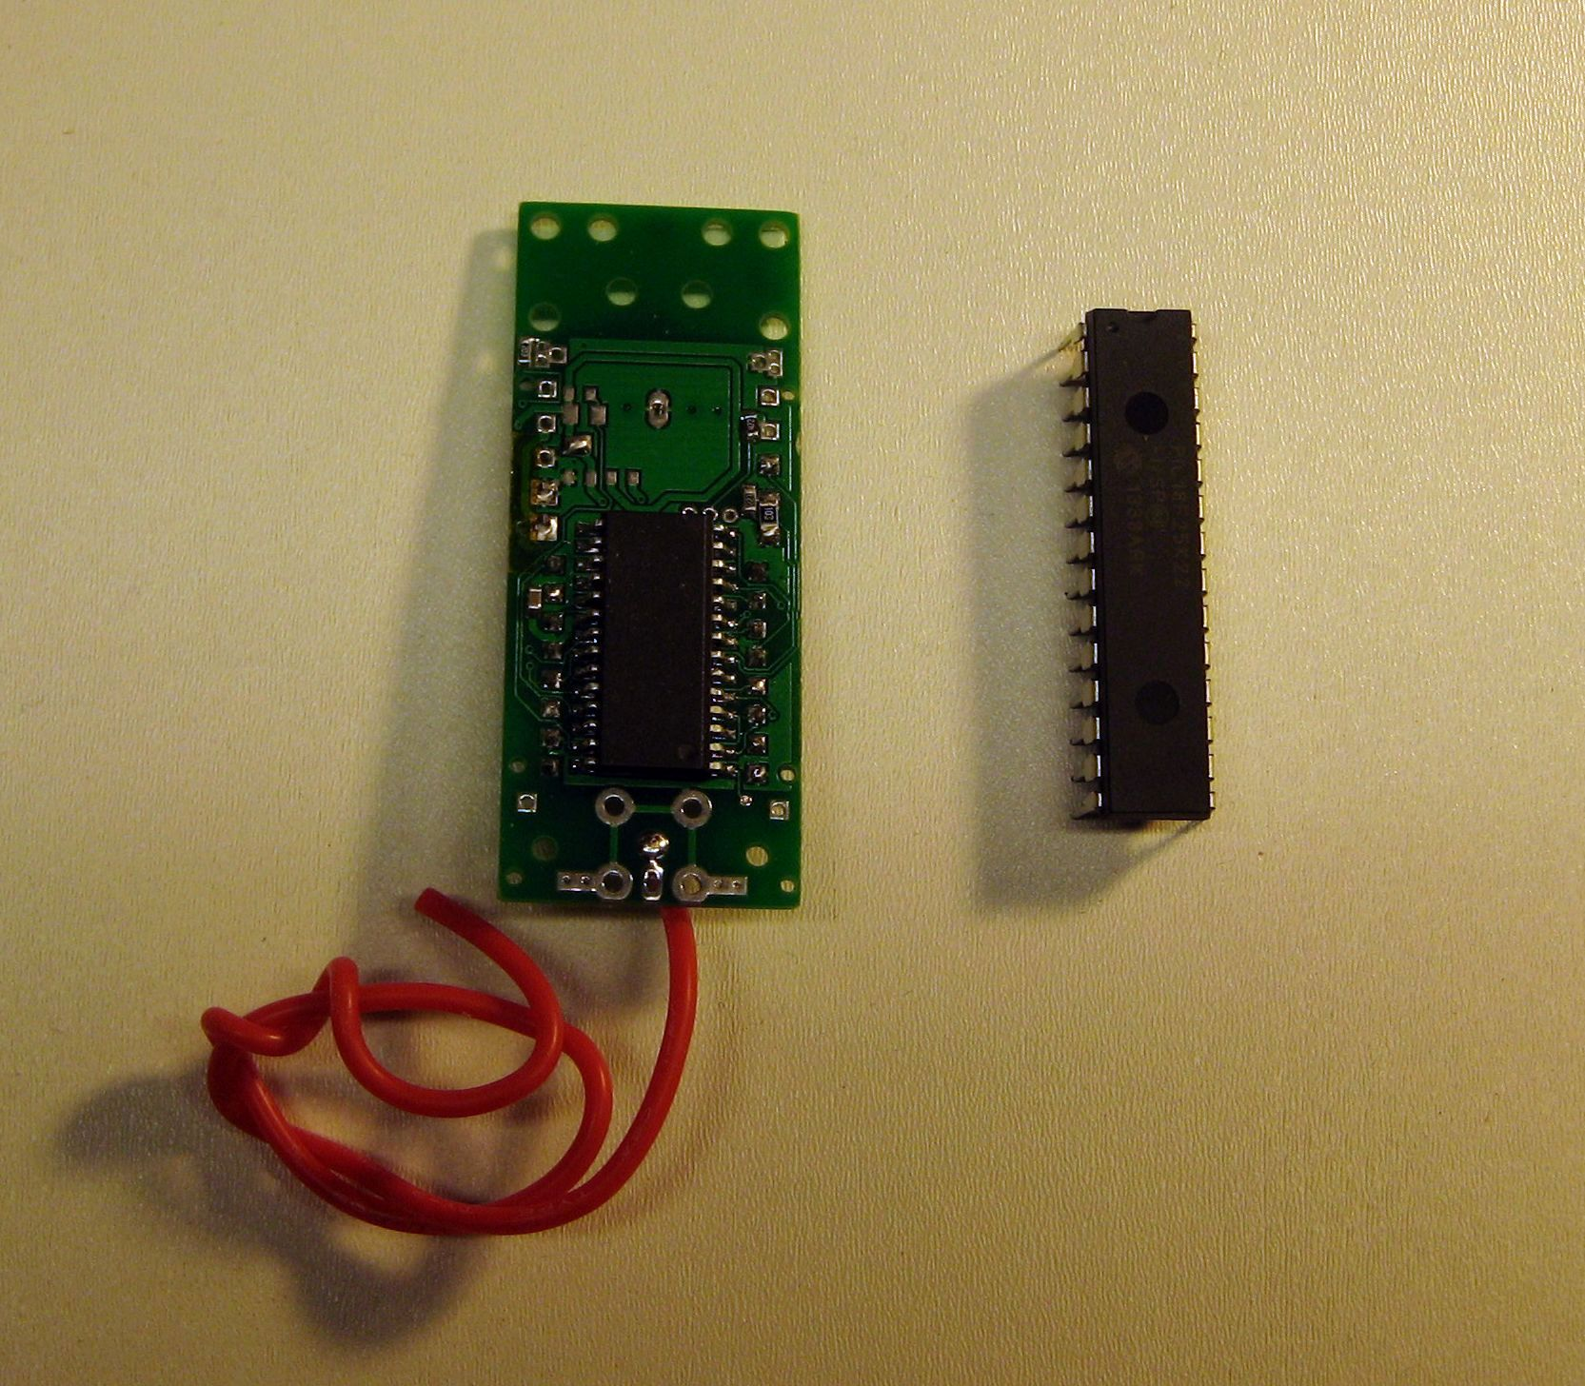

HABAXE3 Pico Tracker

The objective of this first flight of HABAXE2 was to see if the RFM98 device could be used for HAB tracking using the UK limit of 10mW of FSK RTTY and also to see if LoRa digital telemetry had enough range to be a viable alternative.
I had already established in earlier tests that the LoRa telemetry at 1042bps could cover 40km line of sight (LOS) with only 3dBm\2mW and a simple ¼ wave wires with no radials. With the HABAXE2 Pico tracker fitted with a ¼ wave and radials plus a modest base station omni with few dB gain, it was clear that more then 100km was expected at the full 10mW.
Of particular interest to me was making a LoRa base station as simple as possible and that there was also a portable version. To this end two receivers were built, see pictures below, more details of the portable version on the right later.

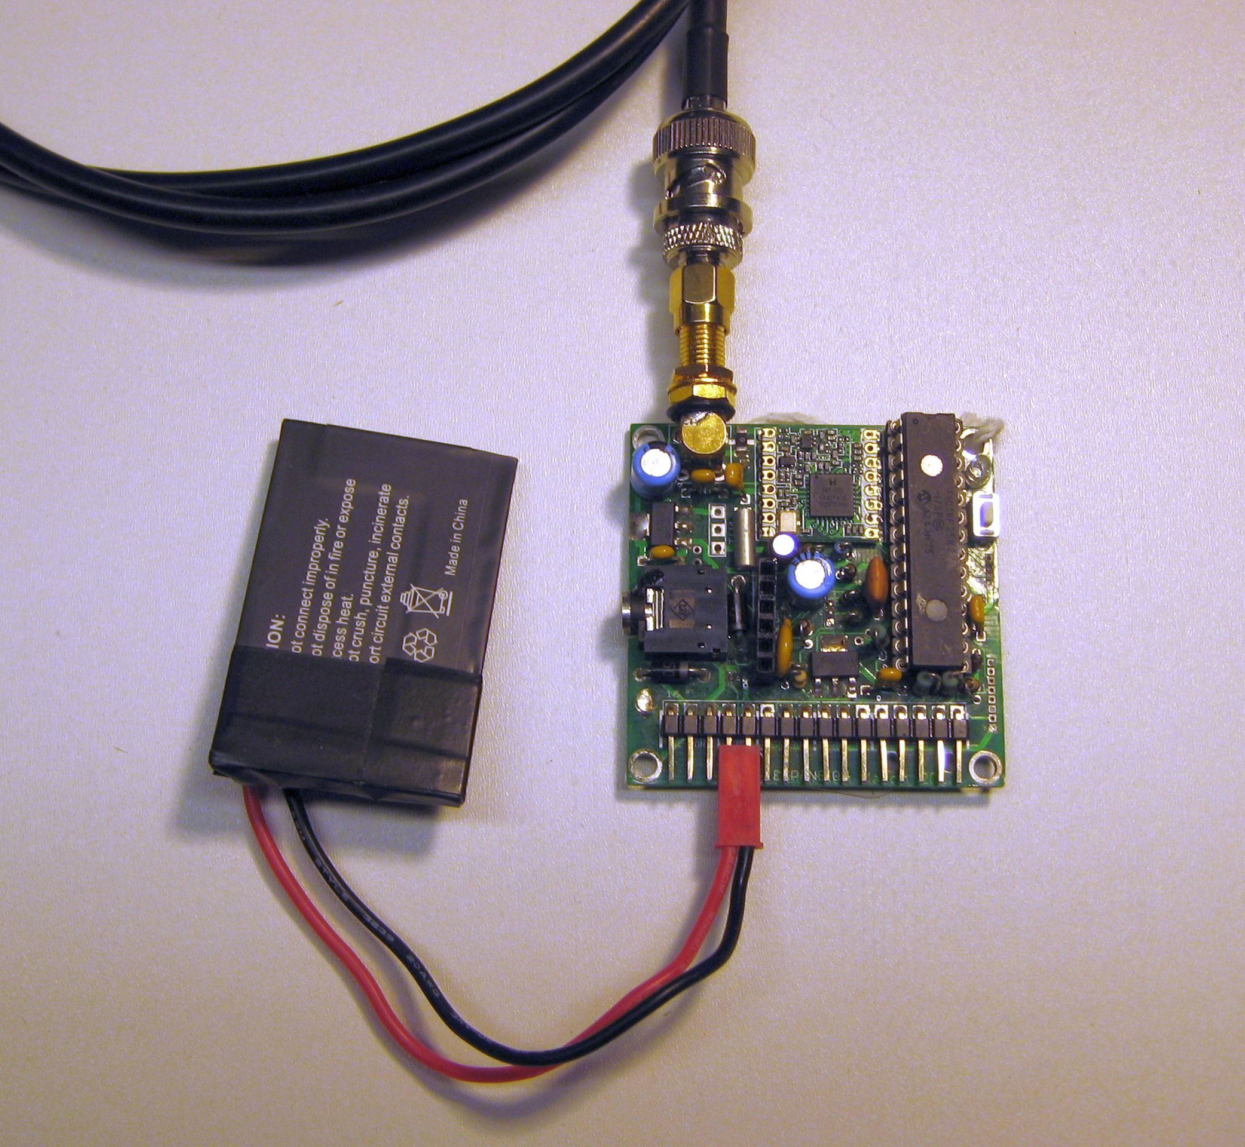
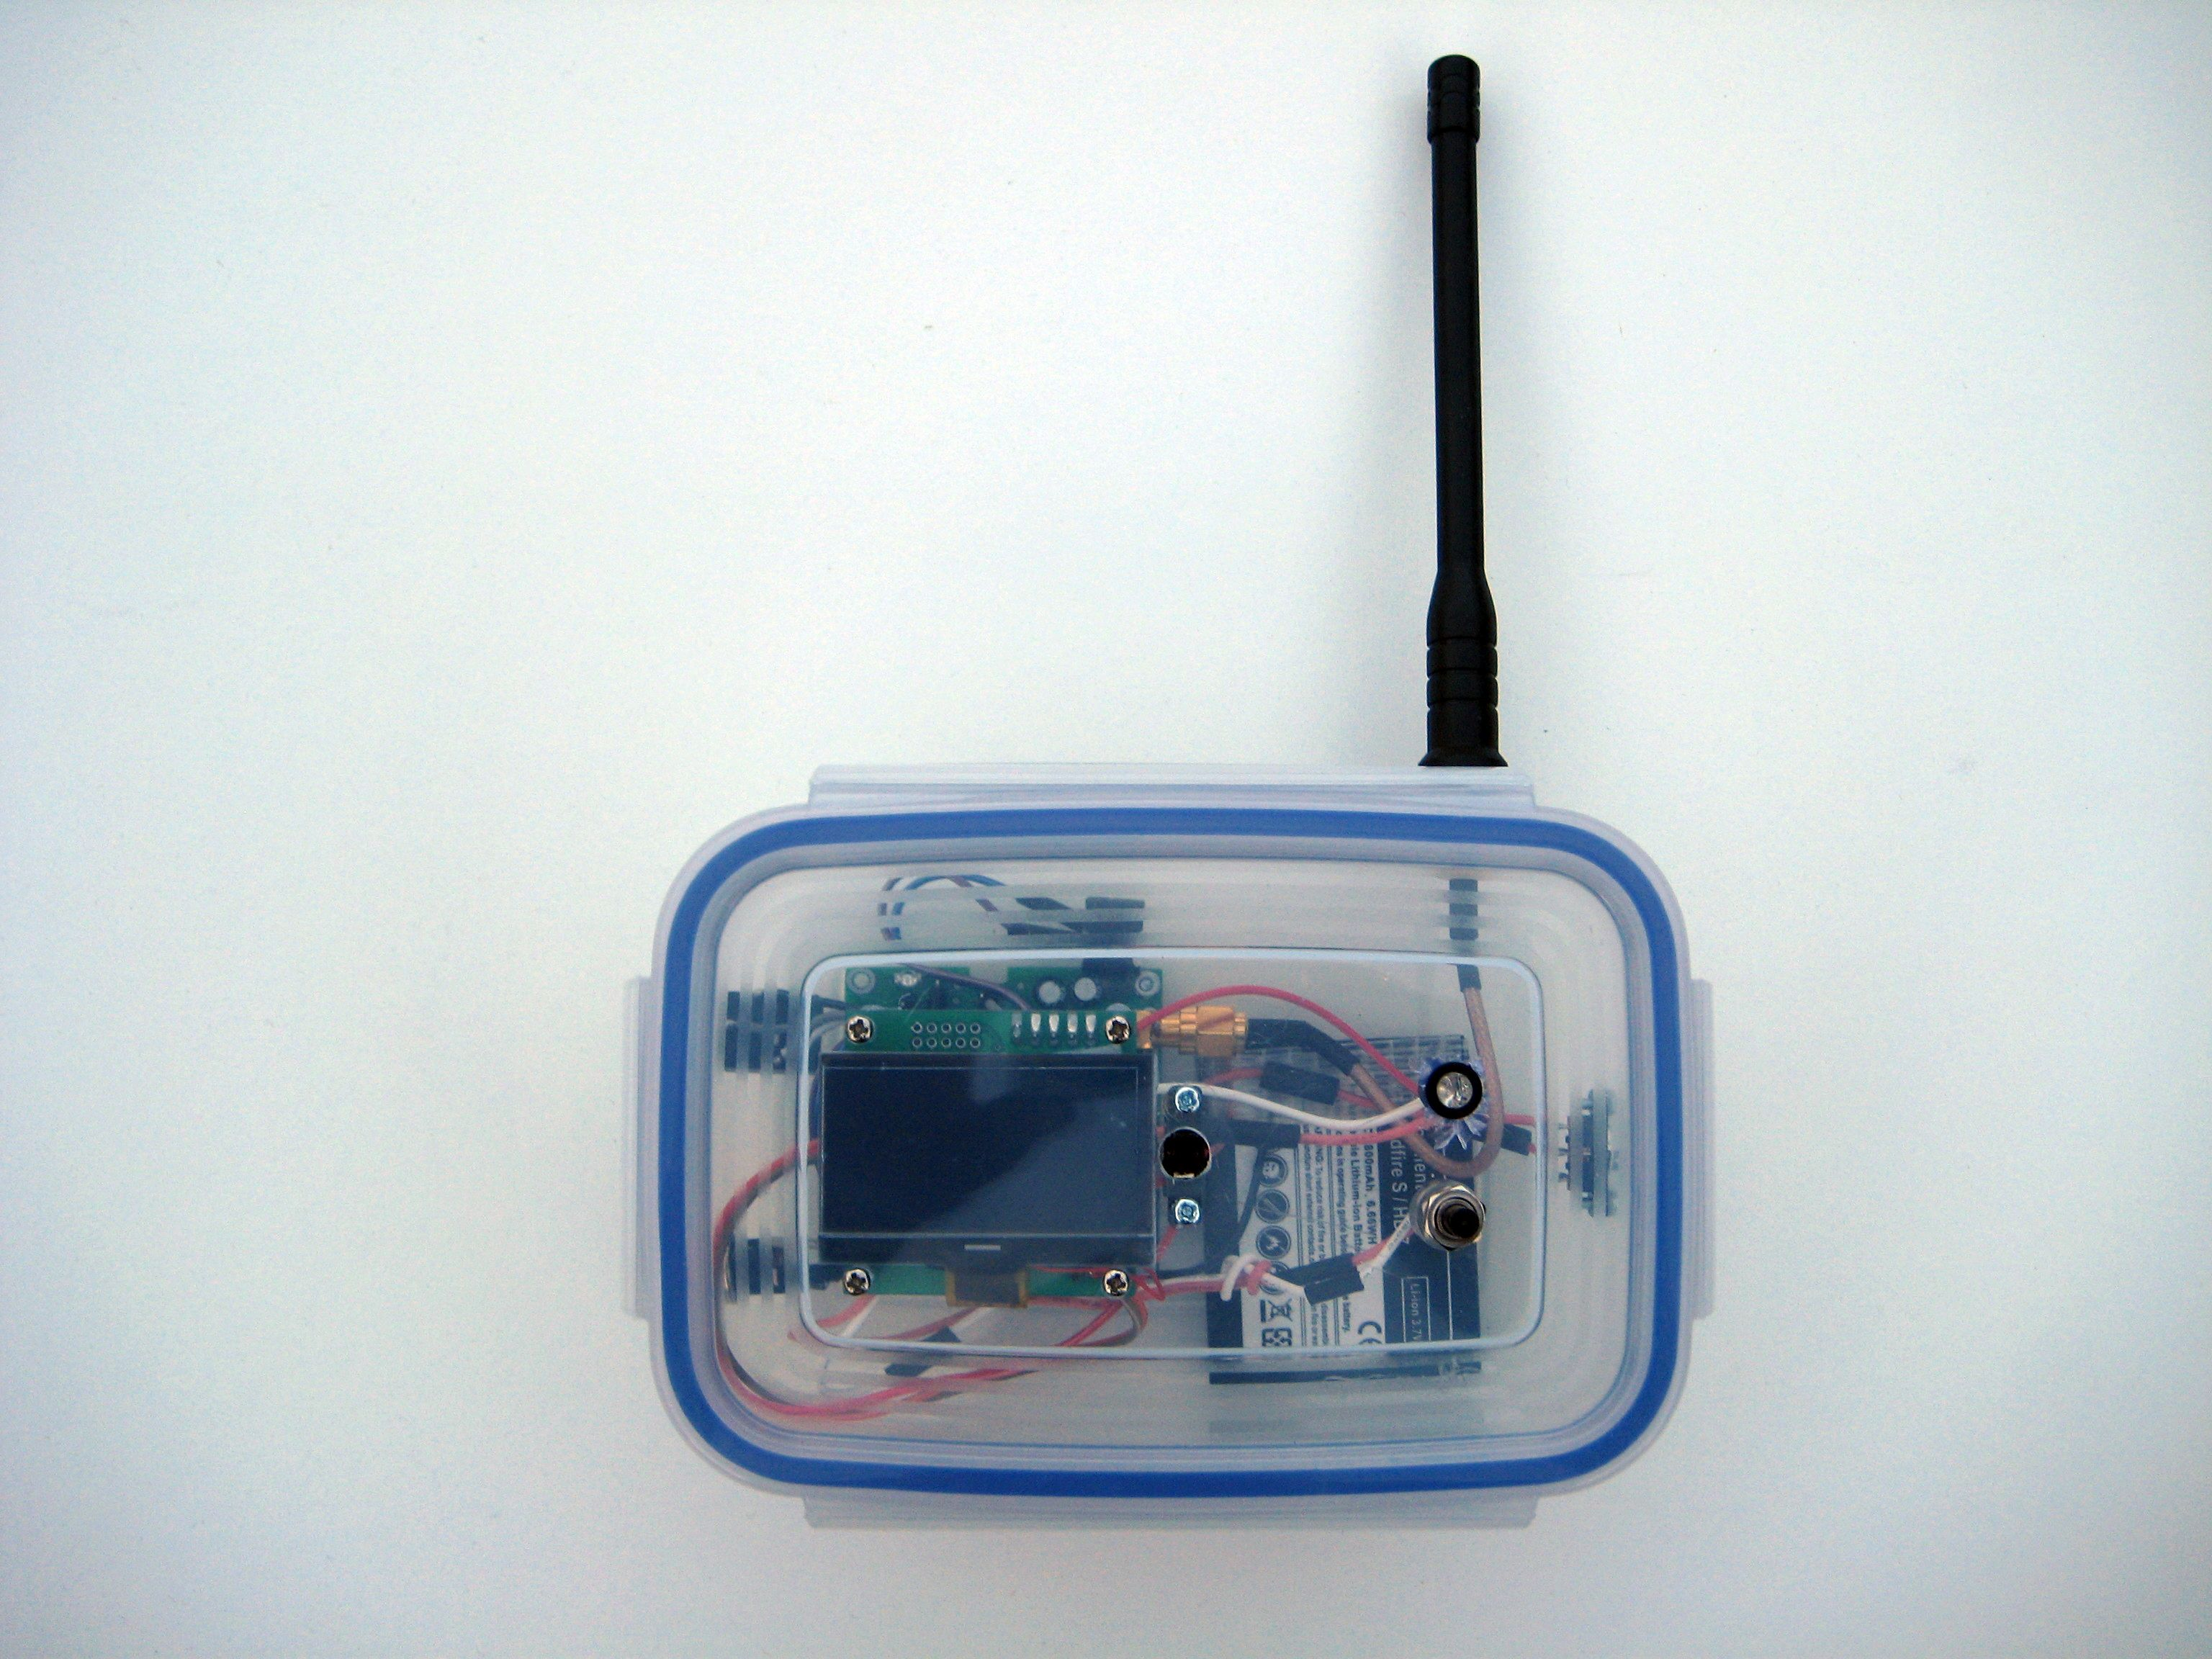

Caerphilly common is a small hill between Cardiff and Caerphilly which rather conveniently has a café and car park nearby. After testing the wind direction HABAXE2 was released and it initially went North West. The cloud was low and it disappeared out of sight in around 30 seconds. Myself and my brother retired for breakfast at the café. A cup of tea with a sausage, egg and black pudding roll went down rather well. With the portable tracker plugged into my net book I was able to watch the track of the balloon as I munched on my breakfast.

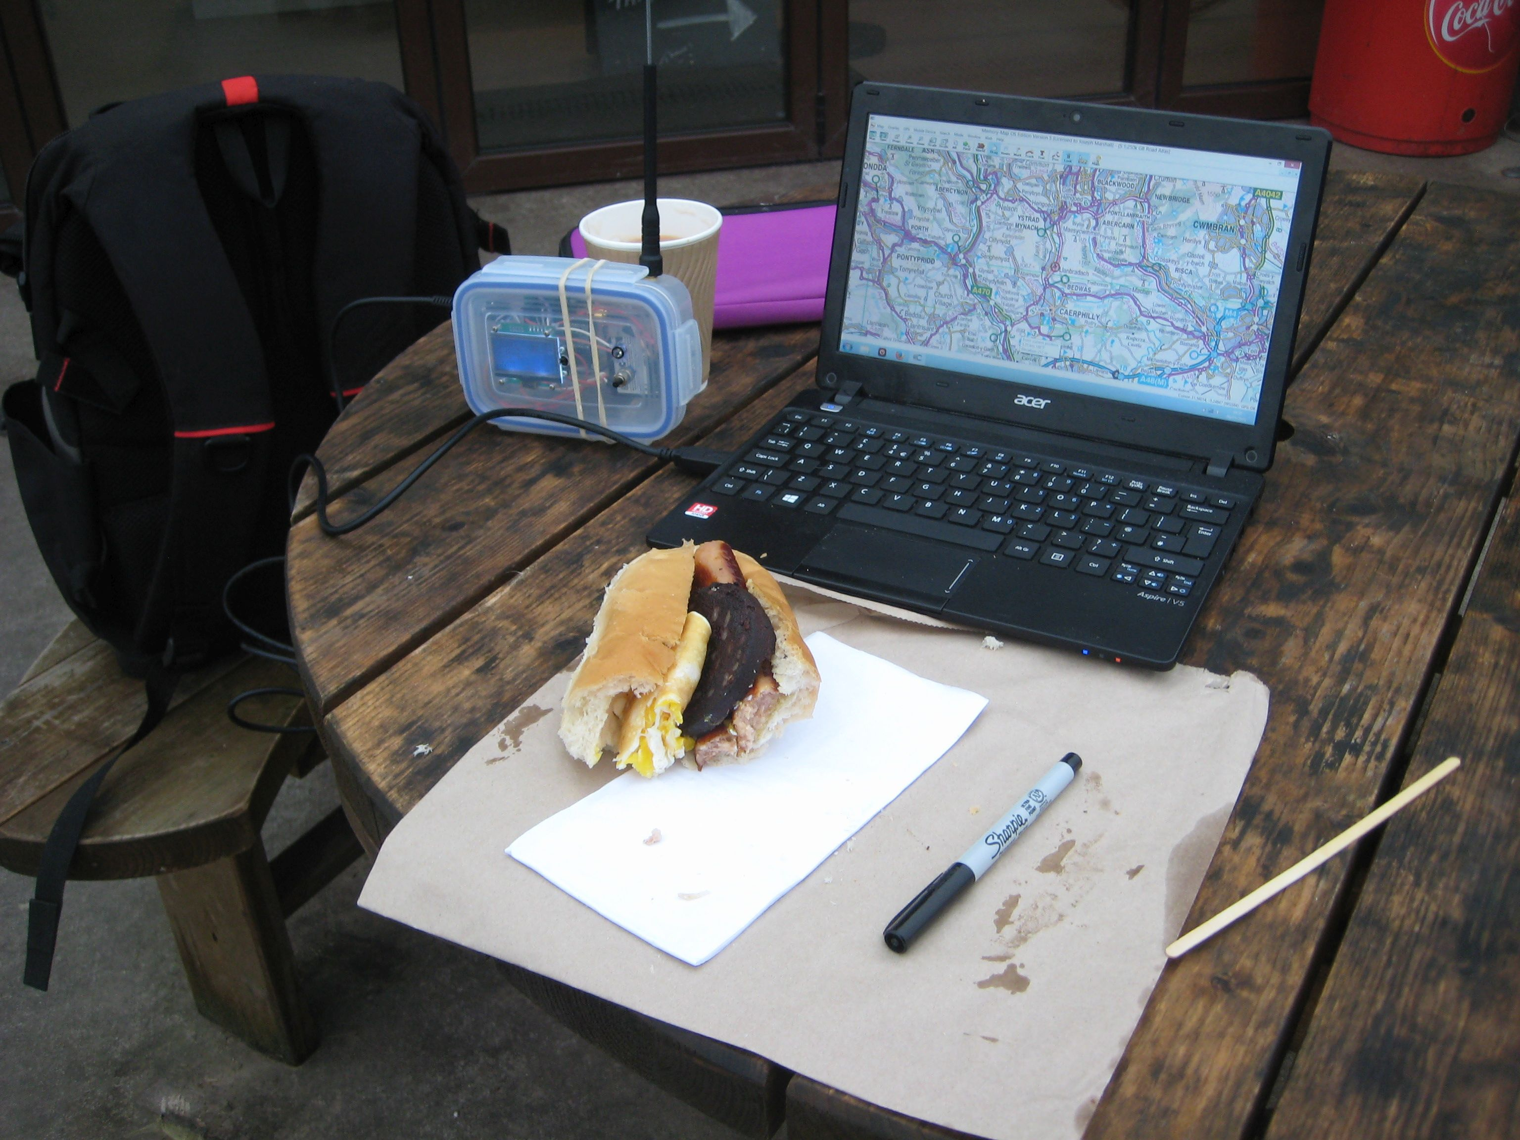

All looked OK, tracker battery, GPS and the balloon climbing. The track was curling round to the South and East as predicted by CUSF so after finishing breakfast I went home to track from there.
Back home I had left the base station receiver running. This receiver was set to receive the LoRa tracker packet and upload it into HABITAT with an AFSK RTTY transmission picked up by my Funcube dongle. The first packet was received whilst I was still in the café 5 miles away and it went into HABITAT OK;

$$HABAXE2,127,09:37:05,51.5372,-3.2062,87,62,357,0,0,0,6,4110,13,Y,0*079A

But then my Funcube\SDR# crashed (it does that) and stopped receiving. I spent the next few hours at home mainly logging the LoRa telemetry.
The main objective of this first flight was to test the capability of the LoRa telemetry. Long distance LOS testing between mountain tops is difficult to arrange over more that a few 10s of kms, but a balloon at an altitude of 6,000 to 8,000M offers the potential for LOS testing up to around 300km.
A command uplink capability was implemented for HABAXE2, the tracker would listen for incoming commands (as LoRa telemetry) for approx 5 seconds just after sending the FSK RTTY. These commands could be used to make the tracker perform various actions, such as warm reset, send RAM variable information or flags for remote diagnostics, send particular NMEA sentences or send a series of descending power packets at a particular set of LoRa modem parameters.
It’s the ability to send descending power packets that would form the basis of the LoRa capability tests. The power level output of the RFM98 can be adjusted in 1dBm steps from 17dBm down to 2dBm. So if you commanded the tracker to send a sequence of packets from 10dBm down to 2dBm, with a particular set of LoRa modem parameters and flipped the base station across to listen with the same set of LoRa parameters, you could measure the effectiveness (and hence distance capability) of the particular mode.
Thus for one test, I used the higher data rates, bandwidth of 500Khz (BW500Khz) spreading factor 7 (SF7) and a coding rate of 4:8 (CR4:8) that gave an equivalent data rate of 13.7kbits according to the LoRa calculator. Part of the test packet payload contained the power level that the packet was sent with.
At my base station I received the above packets down to 7dBm at 105km, the distance was taken from the location of the previous tracker payload.
The main tracker payload and 2 way communications were being done at BW40.7Khz, SF8 and CR4:5, approx 1042bps, so this would have been expected to operate over a longer distance than the 13.7kbps telemetry. Putting a good LNA in the receiver side does help with the low spreading factor rates (lower allowable signal to noise Ratio {SNR}) and in this case my masthead LNA allowed me to receive the same 13.7kbps packets at 2dBm, so an 8dBm margin. Thus at 10dBm it would be reasonable to assume a potential range improvement of 2.5 or a distance of around 250km.
The main tracker payload (same as FSK RTTY) was being sent out as LoRa at the 1042bps rate. The last time this main tracker payload was received error free was at a distance of 269km, and note no LNA was used or needed for this tracking. The antenna used to receive at this distance was an omni Diamond X50N co-linear.
Once the high rate 1042bps packets were out of range at 'only' 279km I could not test communications any further since the command link was also set at 1042bps. However at 242km I did command HABAXE2 to send a series of 98bps SF12 packets which were received error free down to 2dBm\3mW. Extrapolating the 2dBm upwards to 10mw (UK limit) would represent a UK legal range @ 10mW of 611km, which is the radio horizon at an altitude of circa 22km.
There was a problem with the low data rate 98bps packets, the low data rate optimisation bit was not set for the trackers LoRa modem. This did not affect the shorter test packets but the short tracker payload of 22bytes being sent at @ 98bps was being received with CRC errors. For anyone listening out for the 98bps during the flight, if you received it (but got a CRC error) bear in mind that the TX power from HABAXE2 had been set to 2mW only. So at whatever range you received the 98bps during the HABAXE2 flight, it would likely have been received at approx 2.5 times that range assuming the tracker had been set up correctly with the low data rate optimisation bit set and the full 10mW had been used.
I also implemented and tested a method of adjusting the base station frequency to match the tracker frequency which could drift due to the cold. This was done by switching the base station antenna to the Funcube\SDR# and using the SDR# screens frequency cursor to mark the incoming FSK RTTY idle frequency. With the antenna then switched back to the LoRa receiver a menu option allowed a small marker carrier to be sent out which could be shifted up and down via the keyboard to match the frequency cursor on the SDR# screen. This method worked and would be required to allow the LoRa transmissions below 41.7khz to be used.
Thanks to all who assisted in tracking this flight.

Portable LoRa Receiver

One advantage of using telemetry to track high altitude balloons (HAB) is that it's possible to build small battery powered receivers to display tracking information from the HAB tracker in flight or one that has landed and needs to be found.
HAB trackers in the UK normally use FSK RTTY which does have very long range capability, hundreds of km. Whilst this can be received with portable equipment, the minimum set-up is probably a reasonably powerful notebook PC and a Funcube dongle.
In comparison a telemetry receiver can be as simple as a RFM98 PICO tracker board (with suitable software) running from a single Lithium Ion battery and driving a serial LCD display costing around £25 in parts total. The LCD can display the received tracker information such as Latitude, Longitude, altitude, temperature etc.
I have found the best displays for this type of application to be the small Digole serial 128×64 graphic LCDs. These are low power and some versions will run from 3v3 to 5V supplies with no contrast adjustment needed as the supply voltage changes. These serial LCDs need only a single output pin from a micro controller to drive them. The 128×64 displays will show 7 lines of 21 characters at font size 10, there are other font options and graphics too.
I developed a base station receiver board for the RFM98 and PICAXE 28X2 processor that is 50mmx50mm. This forms the basis of my portable LoRa telemetry receiver.

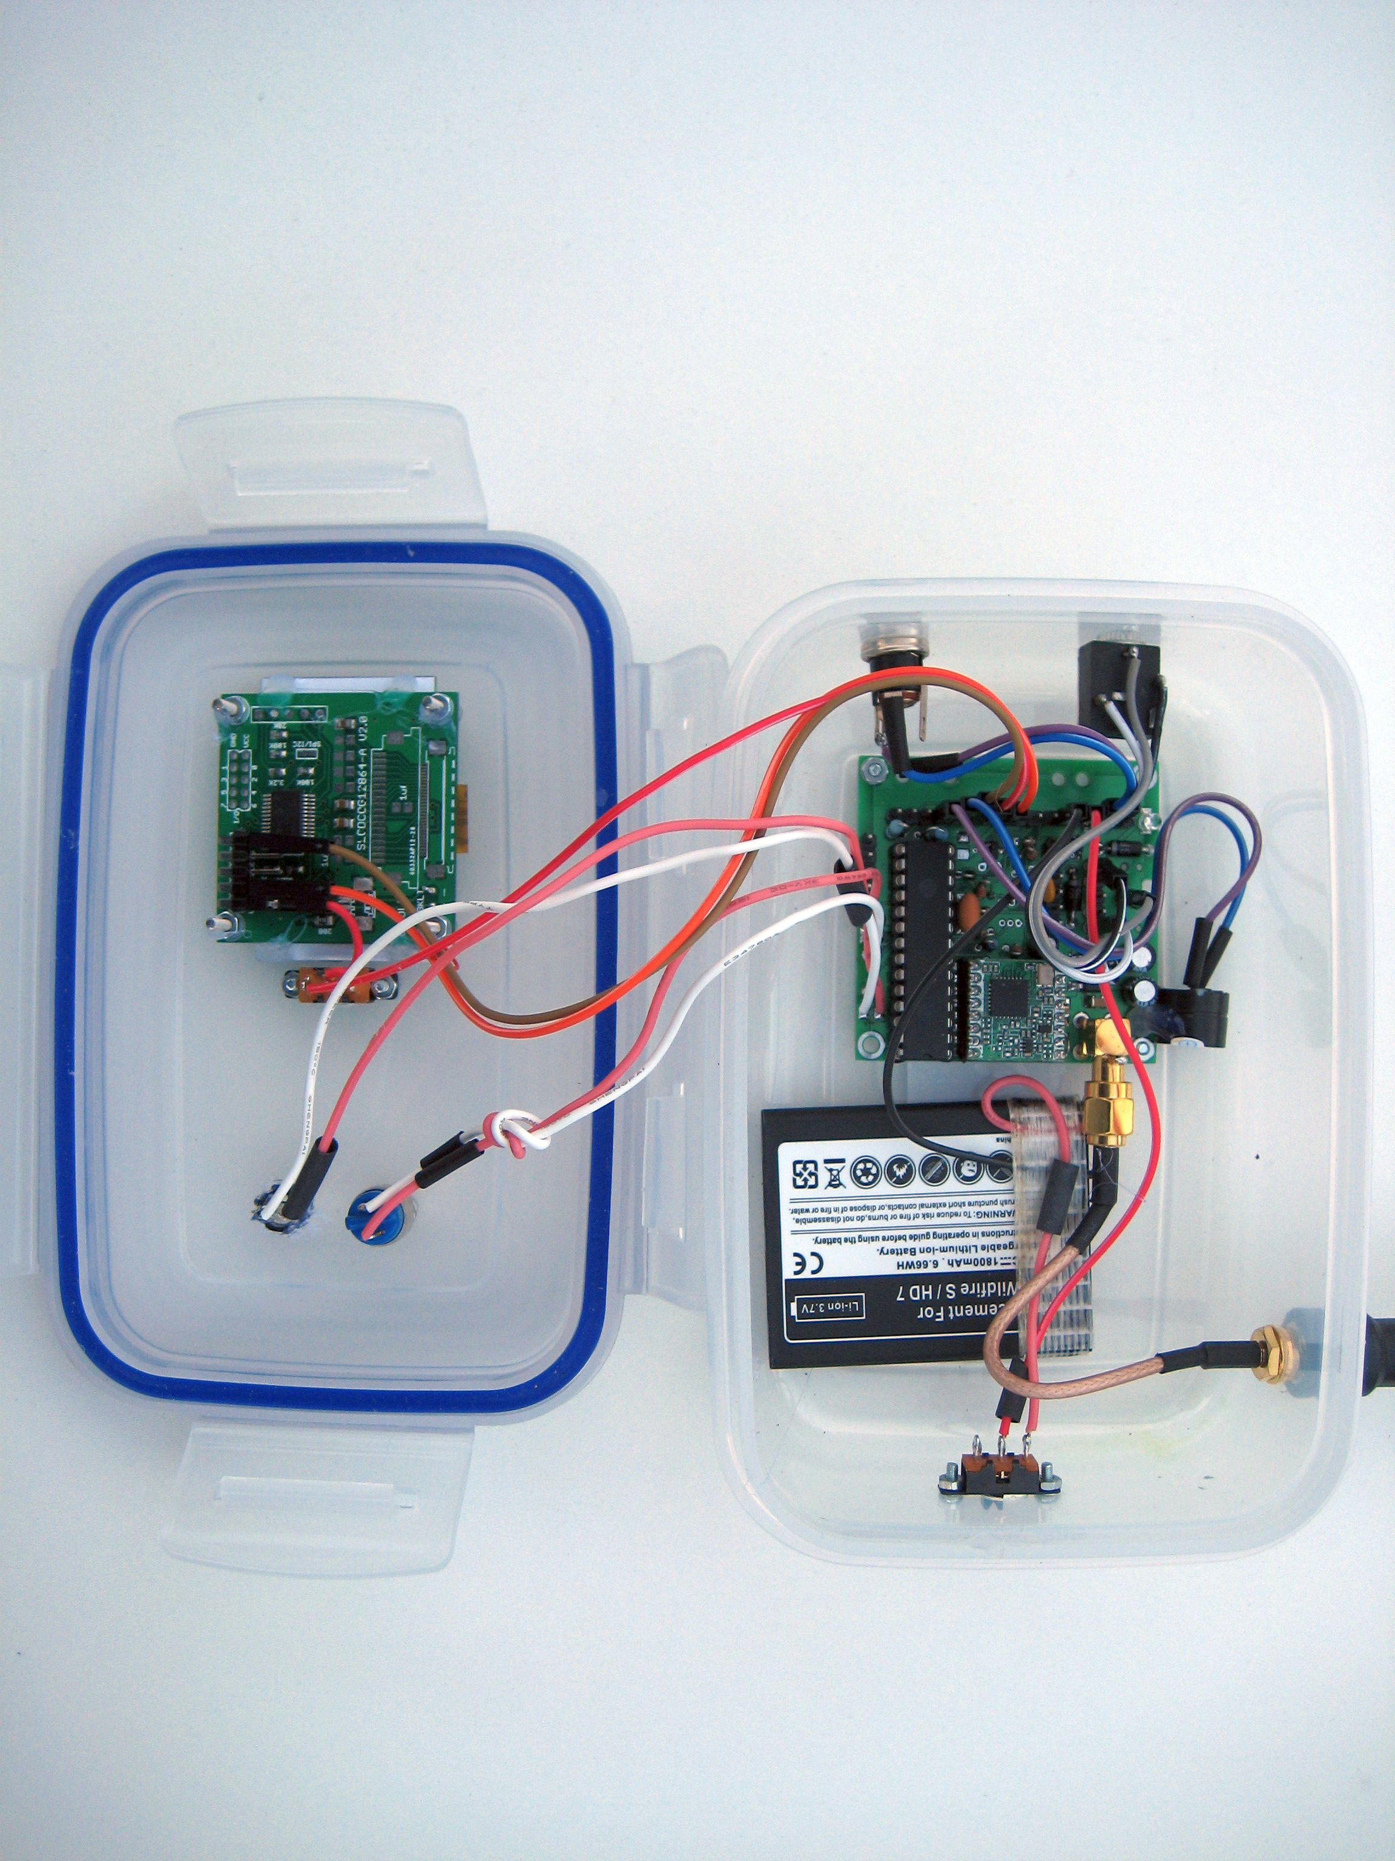

The PCB has connections for the serial LCD, LED, buzzer and switch. The board also incorporates a single cell lithium ion charger IC, so all that’s needed to charge the battery is to connect the external power input to 5V from a USB connection.
The hi-tech case is a clip top food container. These are cheap, robust and easy to work. You don’t even have to cut a hole for the display. For the antenna connection I use a short SMA plug to chassis socket pigtail. A bit of hot melt glue here and there secures the bits in place.
One of the worst cases scenarios for receiving the telemetry is if the tracker (transmitter) is on the ground (lost?) in an urban area as the buildings will cause heavy attenuation of the UHF signals.
The RFM22B telemetry in the urban area around my home with the transmitter on the ground and using a hand-held receiver had a range of around 80m maximum @ 10mW, not a lot of help in locating a lost tracker.
If the 98bps LoRa telemetry contains just the Latitude and Longitude, and assuming this location is correct, how far away can it be received on a portable receiver?
Two options were tested, first just the portable receiver with its rubber duck style antenna and the same receiver connected to a magnetic mount and 4dB gain vertical antenna on a car.
The tracker transmitter was placed with the antenna (a 1/4 wave wire) horizontal on the ground in my garden. I then went for a walk up to see how far away the tracker transmissions were received. reception stopped at 825m, not bad at all.
How far away would the tracker be received by a ‘chase’ car? I left the tracker running and drove to work, I last got the payload from the tracker when I was 2.2km away, a considerable improvement, and clearly viable as a simple means of locating a landed balloon, assuming the GPS location being transmitted is valid of course.

Stuart Robinson
GW7HPW
January 2015

